RESOLUTION NO.__________

RE: CERTIFICATE OF APPROPRIATENESS UNDER THE
PROVISIONS OF THE ACT OF THE PENNSYLVANIA
LEGISLATURE 1961, JUNE 13, P.L. 282 (53
SECTION 8004) AND BETHLEHEM ORDINANCE NO.
3952 AS AMENDED.

WHEREAS, it is proposed reface the projecting sign with the new business signage at 738 E 4th St

NOW, THEREFORE, BE IT RESOLVED by the Council of the City of Bethlehem that a Certificate of Appropriateness is hereby granted for the work.

Sponsored by: (s)

(s)

ADOPTED BY COUNCIL THIS DAY OF

(s)
President of Council

ATTEST:

(s)
City Clerk

HISTORIC CONSERVATION COMMISSION

CASE # 619– It is proposed to reface the projecting sign with the new business signage at 738 E 4th St.
OWNER/APPLICANT: 738 E. Fourth Street, LLC / Rice ‘N Beans To Go

The Commission upon motion by Mr. Lader seconded by Mr. Hudak adopted the proposal that City Council issue a Certificate of Appropriateness for the proposed work described herein:

- The proposal to reface the projecting sign with the new business signage at 738 E 4th St. was represented by Marco Justo.

- The new sign will read “Rice ‘N Beans, Puerto Rican & Mexican Fusion Restaurant” and be redesigned as discussed at the meeting and sketched by the Historic Officer.

- “Delivery, Take out, Catering” and the telephone number will be in vinyl lettering on the window and not on the projecting sign.

- The sign will have a red background with yellow and white lettering. The oval will have yellow and black borders, and the sign will have a pinstripe around the perimeter in yellow or black.

- The sign will have cut out corners as shown in the sketch.

- The sign will hang from the existing black scroll bracket.

- The motion to approve the proposal was unanimously approved.

CU: cu
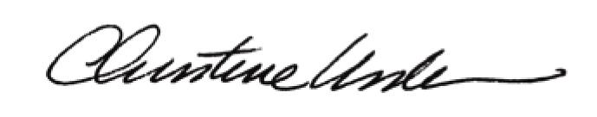

By:

Date of Meeting: July 17, 2017 Title: Historic Officer

